- Load Balancers change IP all the time so we can’t use Route 53’s A record
- Instead we use Alias Record and assign Load Balancer’s DNS to it.

Stateless Web App: WhatIsTheTime.com
• WhatIsTheTime.com allows people to know what time it is
• We don’t need a database
• We want to start small and can accept downtime
• We want to fully scale vertically and horizontally, no downtime
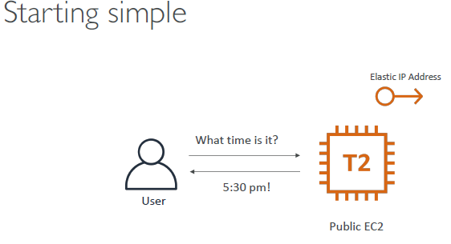
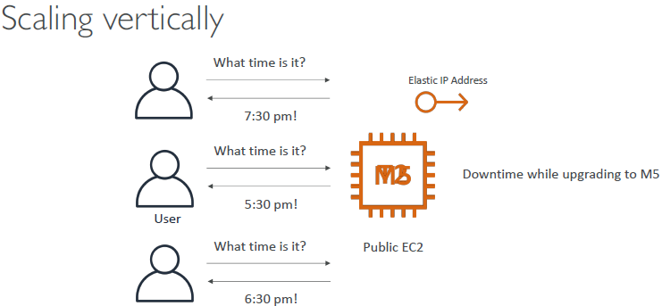
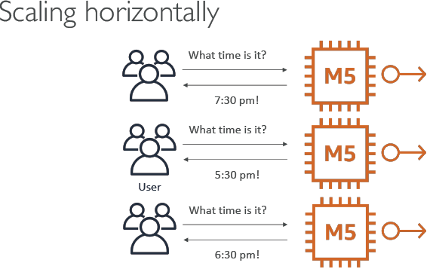
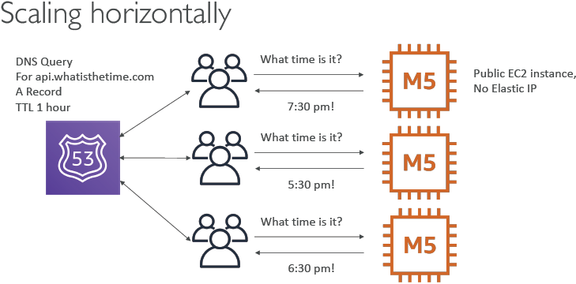
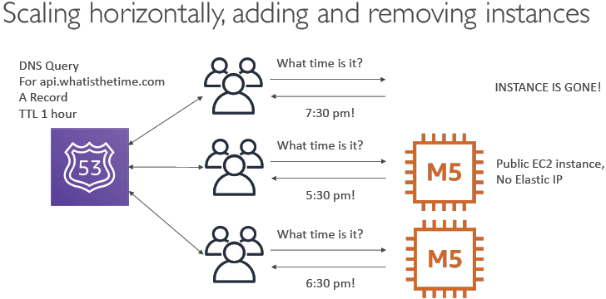
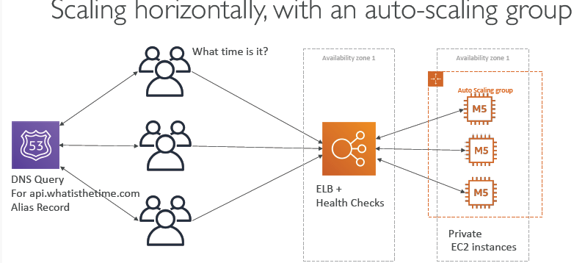
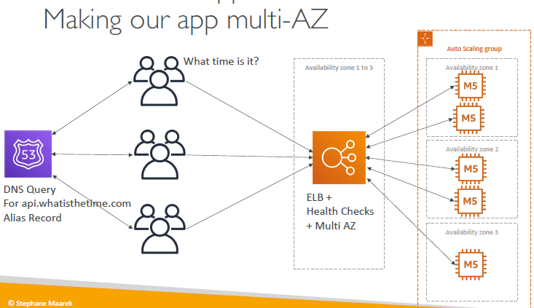
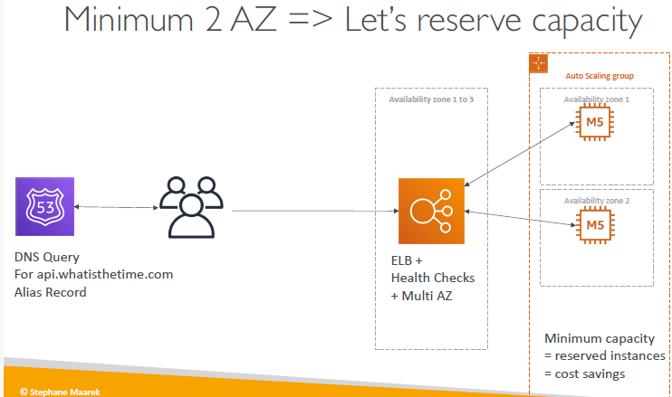

Conclusion SA job is to compare and give the best and most optimal cloud service for our client:
• Public vs Private IP and EC2 instances
• Elastic IP vs Route 53 vs Load Balancers
• Route 53 TTL, A records and Alias Records
• Maintaining EC2 instances manually vs Auto Scaling Groups
• Multi AZ to survive disasters
• ELB Health Checks
• Security Group Rules
• Reservation of capacity for costing savings when possible

MyClothes.com
• MyClothes.com allows people to buy clothes online.
• There’s a shopping cart
• Our website is having hundreds of users at the same time
• We need to scale, maintain horizontal scalability and keep our web application as stateless as possible
• Users should not lose their shopping cart
• Users should have their details (address, etc) in a database
Add Session Stickiness ELB this will always redirect user to the same EC2 instance that they add items to their Cart to prevent session data loss due to ELB redirect user with cart data in AZ 1 to AZ 2 which doesn't have the Cart session data of the user just added in.

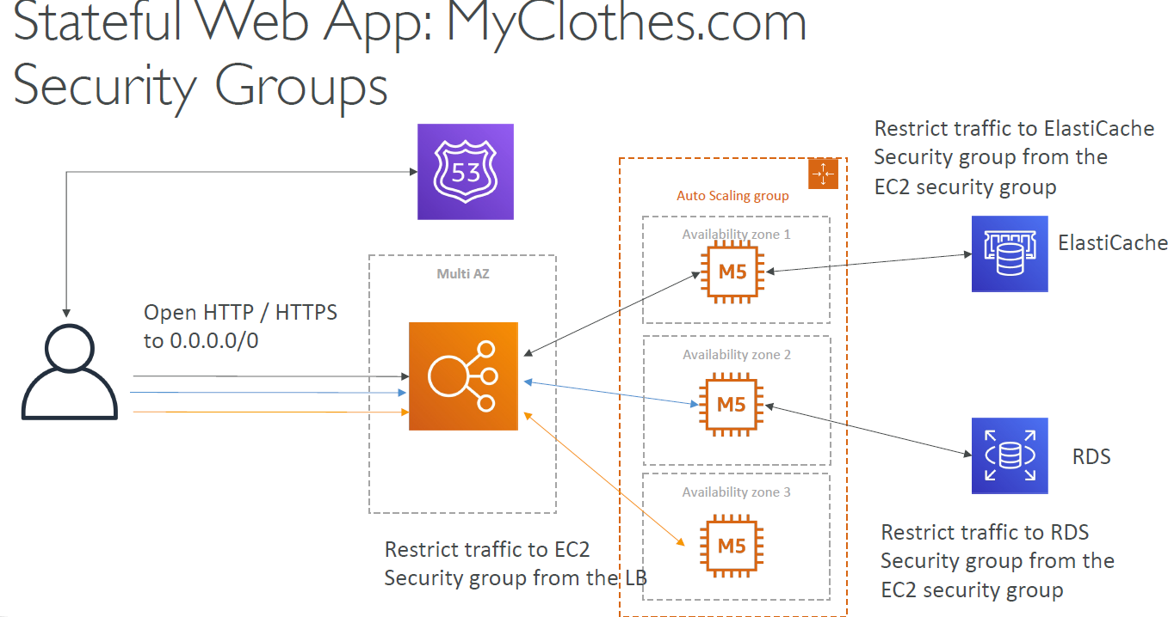
- We apply 3-tier architectures for web applications
- ELB stick session: to redirect user to the same instance to prevent session data loss
- Web clients for storing cookies and making our web app stateless
- ElastiCache:
  - For storing session (alternative: DynamoDB)
  - For caching data from RDS to reduce amount of requests access the EC2 instances and RDS
  - Multi AZ

- RDS:
  - For storing clothes store online data
  - Read replicas for significantly increase the query speed and make browsing and searching clothes on the site faster
  - Multi AZ for disaster recovery
-Tight Security with security groups referencing each other to preventing other can access to private EC2 group or directly access to RDS database. Only public access for Route 53 and public Load Balancer

MyWordPress.com
• We are trying to create a fully scalable WordPress website
• We want that website to access and correctly display picture uploads
• Our user data, and the blog content should be stored in a MySQL database
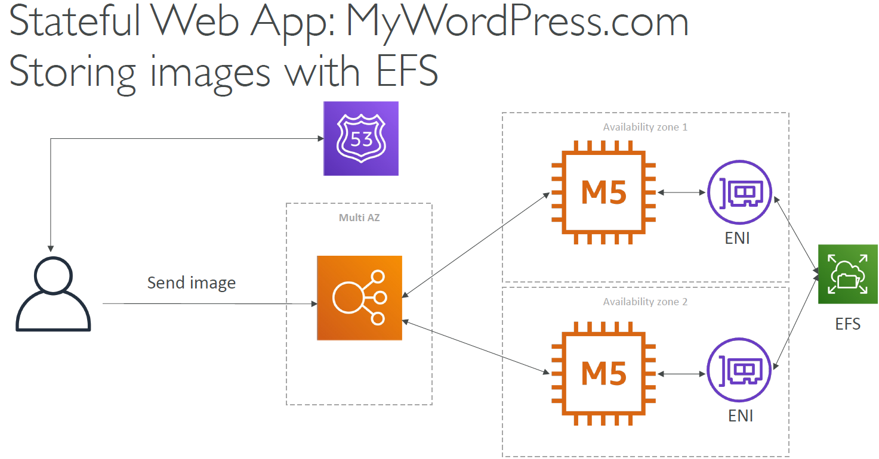
Elastic File System will be used to storage picture uploaded to EC2 instance and since EFS shared across all instance with Elastic Network Interface VPC and within same Region all your EC2 instances will have all the pictures available to display on WordPress website by access data of EFS
- Aurora Database to have easy Multi-AZ and Read-Replicas
- Storing data in EBS (single instance application)
- Vs Storing data in EFS (distributed application)

Instantiating Application quickly
EC2 instances:
- Use a Golden AMI: install your apps, OS dependencies etc before hand and launch EC2 instance from the Golden AMI
- Boostrap using User Data: For dynamic configuration use User Data scripts
- Hybrid: mix Golden AMI and User Data (Elastic Beanstalk)
RDS Databases:
- Restore from a snapshot: the db will have schemas and data ready

ELASTIC BEANSTALK
- Elastic Beanstalk is a developer-centric view of deploying an application on AWS
- It allow user to manage all the component we’ve seen before like EC2, ASG, ELB, RDS,….
- It’s a MANAGED SERVICE:
  - Automatically handles capacity provisioning, load balancing, scaling, application, health monitoring, and instance configuration.
  - You only have to manage your own code as a developer
- Beanstalk is free but you pay for the underlying instances and services your enabled.
- Components - Elastic Beanstalk
- Application: collection of EB components (environments, versions, configurations,...)
- Application version
- Environment:
  - Collection of AWS resources running an application version
  - Tiers: Web Server Environment Tier & Worker Environment Tier
  - You can create multiple environments (dev, test, prod,….)
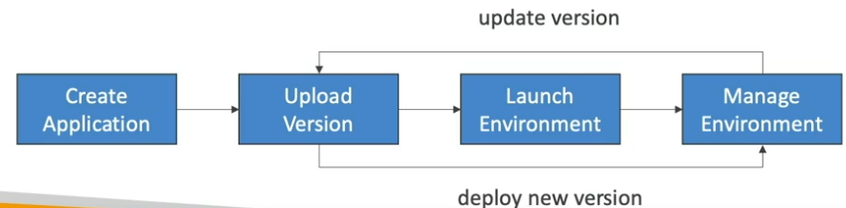
- Supported Platforms – Elastic Beanstalk
- Go
- Java SE
- Java with Tomcat
- .NET Core on Linux
- .NET on Windows Server
- Node.js
- PHP
- Python
- Ruby
- Packer Builder
- Single Container Docker
- Multi-container Docker
- Preconfigured Docker

- Web server tier vs Worker tier

Elastic Beanstalk – Hands-on
First go to Elastic Beanstalk then create Application then input name
Step1 : create Environment:
- Choose Environment tier: Web server environment or Worker environment
- Application information
- Environment information: Input Environment name, input domain
- Platform: Choose suitable Platform aka main programming language your app will be running on and that platform version. Ex: Platform Node.js, branch: Node.js 18, Platform version: 6.2.2
- Application code: allow you to select Sample application or Existing version in your S3 or Upload your code build files
- Preset: select preset tier
Step 2: Configure service access (role)
Go into IAM > Role > Create new Role > AWS Service > EC2
Permission policies: Select AdministratorAccess-AWSElasticBeanstalk, AWSElasticBeanstalkMulticontainerDocker, AWSElasticBeanstalkWebTier, AWSElasticBeanstalkWorkerTier, AWSElasticBeanstalkManagedUpdatesCustomerRolePolicy
Then press Next and input role name. Ex: “aws-elasticbeanstalk-ec2-role-2024”. You can review and change Trust policy script if you want.
Step 3: Networking and database
Choose suitable VPC with multiple AZ
Step 4: Instance Traffic and Scaling
- Choose suitable security group that only allow public access through the Load Balancer and set EC2 instances security as private
Step 5 : optional
Step 6: Review
Result is a domain name: http://mynodejsapplication-env-1.eba-xmmkfxde.ap-southeast-1.elasticbeanstalk.com/
And new CloudFormation will be created for the Elastic Beanstalk environment
“awseb-e-fxfhtyssks-stack”
New instance, Elastic IP and Auto scaling group also being created

QA
Question 1:
Your website TriangleSunglasses.com is hosted on a fleet of EC2 instances managed by an Auto Scaling Group and fronted by an Application Load Balancer. Your ASG has been configured to scale on-demand based on the traffic going to your website. To reduce costs, you have configured the ASG to scale based on the traffic going through the ALB. To make the solution highly available, you have updated your ASG and set the minimum capacity to 2. How can you further reduce the costs while respecting the requirements?
Answer: Reserve two EC2 instances
Explain: An Amazon Reserved Instance (RI) is a billing discount that allows you to save on your Amazon EC2 usage costs. When you purchase a Reserved Instance, you can set attributes such as instance type, platform, tenancy, Region, or Availability Zone1. RIs grant a discount of up to 72% compared to on-demand instance rates
Question 2:
Which of the following will NOT help us while designing a STATELESS application tier?
Answer : EBS volumes are created in a specific AZ and can only be attached to one EC2 instance at a time.
Question 3:
You want to install software updates on 100s of Linux EC2 instances that you manage. You want to store these updates on shared storage which should be dynamically loaded on the EC2 instances and shouldn't require heavy operations. What do you suggest?
Answer: Store the software updates on EFS and mount EFS as network drive to the instances at startup
Explain: EFS is a network file system (NFS) that allows you to mount the same file system to 100s of EC2 instances. Storing software updates on an EFS allows each EC2 instance to access them.

Question 4:
As a Solutions Architect, you're planning to migrate a complex ERP software suite to AWS Cloud. You're planning to host the software on a set of Linux EC2 instances managed by an Auto Scaling Group. The software traditionally takes over an hour to set up on a Linux machine. How do you recommend you speed up the installation process when there's a scale-out event?
Answer: Use a Golden AMI
Explain: Golden AMI is an image that contains all your software installed and configured so that future EC2 instances can boot up quickly from that AMI.
Question 5:
You're developing an application and would like to deploy it to Elastic Beanstalk with minimal cost. You should run it in SINGLE INSTANCE MODE
Question 6:
You're deploying your application to an Elastic Beanstalk environment but you notice that the deployment process is painfully slow. After reviewing the logs, you found that your dependencies are resolved on each EC2 instance each time you deploy. How can you speed up the deployment process with minimal impact?
Answer: Create an Golden AMI that contains the dependencies and use that image to launch the EC2 instances
Explain: Golden AMI is an image that contains all your software, dependencies, and configurations, so that future EC2 instances can boot up quickly from that AMI.

